Preliminary Layout

System Information

Project Information

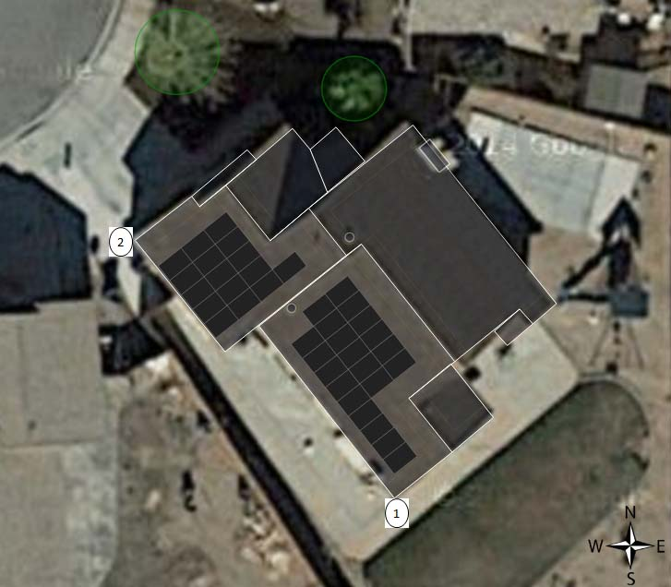

Name:

Address:

Phone:

|  |  |  |  |
| --- | --- | --- | --- |
| Module make & Type: SolarWorld, SW260 Mono | | | |
| Roof Information: | | | |
| Roof | Mod. Qty | Tilt | Azimuth |
| 1 | 21 | 25 | 230 |
| 2 | 16 | 18 | 230 |
|  | | | |
| Total module qty: 37 | | | |
| System capacity: 9.62kW | | | |

